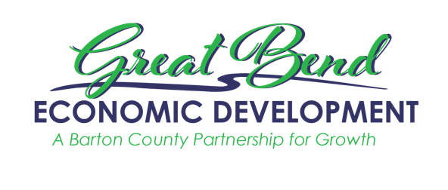
Great Bend Economic Development
3111 10th Street
Great Bend, KS 67530
(620) 796-2407
marketing@gbedinc.com
www.gbedinc.com

For Immediate Release:
August 16, 2022

Great Bend Economic Development commemorates Apprenticeship Champion, KMW Loaders

On September 1, 2022 at 10 a.m., Great Bend Economic Development will celebrate local Apprenticeship Champion, KMW Loaders, at their Great Bend Plant, 198 US 281. This event honors KMW Loaders launching a new apprenticeship program partially funded by State and Federal programs. With the assistance of Hamilton-Ryker’s workforce development division, TalentGro, KMW Loaders was connected to government investment, both State and Federal, to equip local businesses with workers with skills needed to help the business thrive and grow. Three new apprentices begin their journey into a career in manufacturing with the launch of this new apprenticeship program at KMW Loaders. Great Bend Economic Development will host the media, community leaders, as well as other businesses interested in taking part in the program. During the presentation of the Apprenticeship Champion award to KMW Loaders from GBED, there will be a press conference, Q&A about apprenticeships, and a short tour of KMW Loaders. Following the event, businesses are invited to learn more about the apprenticeship program from GBED and Hamilton-Ryker/TalentGro at an informational session. For more on the informational session please call GBED at 620-796-2407, register online at: www.gbedinc.com/gbwc, or email: marketing@gbedinc.com.

Apprenticeship programs can help not only attract people to Kansas while keeping young Kansans from leaving. The state of Kansas received the SAEEI (State Apprenticeship Expansion, Equity and Innovation) Grant, awarding just under $6 million in funding to assist in this expansion effort statewide. Multiple partners working with the Kansas Department of Commerce will receive these funds, and KMW will be the first business to take advantage of this opportunity in Barton County. This opportunity will help the local manufacturer in developing their talent. Hamilton-Ryker/TalentGro not only connects employers to the grants and funding available to support this effort but also assists the employer in building, launching, and managing the program.

Apprenticeships are generally regarded as a positive program to help workers gain experience and knowledge; they need to be hirable members of the workforce. Unlike internships, apprenticeships are paid and frequently include a track to being hired full-time. The length of an apprenticeship depends on both the sponsor and the job. The range can be anywhere from one year up to six years, however, the average apprenticeship lasts two years.

To learn more about how to become an Apprenticeship Champion or join the apprenticeship program as an employee, please contact GBED via email at director@gbedinc.com or by calling 620-796-2407. GBED connects employers to partners like Hamilton-Ryker to grow Barton County businesses.

The KMW Difference:
At KMW Loaders, we combine innovative engineering, modern manufacturing technology, and expert craftsmen to have all the right ingredients for building great front-end loaders and backhoes. That’s why we have a 30-year track record of success and continue to grow rapidly. We look to continue to grow well into the future as we are very focused on growing our company and team. KMW is making huge investments in many new pieces of equipment and tools to help us handle the growth and expansion. This is being done with a strong long-range vision of continuing to grow our company and team together.

Working at KMW isn’t just a job – it’s an opportunity for your work to challenge you, continue learning, and grow with us. KMW is a big believer in career development and promoting employees from within our company. We are always looking for hard-working and valuable employees to add to our team. Our manufacturing plants are conveniently located in beautiful Sterling, Lyons, and Great Bend, Kansas.

About GBED (Great Bend Economic Development):
Our goal is to sustain long-term economic health and vitality of the County through the retention, expansion, and attraction of businesses and development that enhance property values, increase personal income, and make a positive contribution to the quality of life of the citizens of Barton County.

Great Bend Economic Development leads the charge in creating workforce initiatives to sustain our current employers as well as initiatives that will help to support new employers that move to the community. Employers and jobseekers are encouraged to reach out to GBED with questions and concerns and GBED will either pair you up with a workforce partner to help you accomplish your goals, or work with you one-on-one to create solutions and positive outcomes. Together we will create a strong and sustainable workforce pipeline that will enable us to continue to grow Barton County.

